PAPER TITLE (Arial/Arial Nova, 12 pt, negrita)

Author A^{1*,2}, Author B² (Arial/Arial Nova, 12 pt)
¹Affiliation, address (Arial/Arial Nova, 10 pt).
²Affiliation, address (company/university/research centre).
*Main author contact email (Arial/Arial Nova, 10 pt)

Abstract

Authors are kindly requested to read the speaker instructions document on the Annual Meeting website under the "papers" section.
The call for abstracts will be announced on March 5, at the end of the Operational Experience Day. The deadline to submit abstracts will be Friday, May 15. After this date, authors who have successfully submitted their abstracts can submit their papers by Friday, September 18, to be eligible for an award. After this date, it will still be possible to upload the paper, but it will not be eligible for an award. This year, presentations will be uploaded to the Annual Meeting platform. Presentations can be uploaded to the platform until Friday, October 2 at 12:00 am. Authors are kindly requested to upload their presentations on time to avoid delaying the technical session and causing inconvenience to their colleagues and the technical and social program. All presentations will be downloaded onto the room computers on Monday afternoon. It is recommended to have the presentation on a USB drive in case of loss.

KEYWORDS: ANNUAL, MEETING, SPANISH, NUCLEAR, SOCIETY

INTRODUCTION (STYLE «TÍTULO 1»)
This template is a Word document; however, the written presentation must be uploaded in PDF format. The title of each main section is numbered, left-aligned, in uppercase, and Arial Nova / Arial font with size 10 (style 'heading 1').
The paper will be uploaded to the website in PDF format. The name will follow the format SS-NN_title.pdf, where SS represents the two digits corresponding to the session to which the presentation has been assigned, followed by a hyphen (-), NN is the presentation's order number within the session, followed by an underscore (_), and finally an acronym (up to 15 characters without spaces) of the presentation title, which, as expected, will be the same as or very similar to the synopsis. The digits SS and NN will be communicated to you by the Technical Committee of the Annual Meeting after the preparation of the Preliminary Technical Program.
There is no indentation on the first line of each paragraph, and Arial Nova or Arial font in size 10 is always used for the body of the text, which is justified. You can find the body text style in the style gallery as "normal." The reference style used is IEEE. There can be five types of references: scientific journal article [1], journal article [2], conference article [3], book or manual [4], and webpage [5]. The document must have a maximum length of 8 pages.
Remember, for your presentation during the Annual Meeting, if you wish to use any unconventional audiovisual media, you must notify the Technical Session coordinator and the assigned Technical Area responsible in advance to confirm the availability of the necessary equipment in the room.

SECOND SECTION
When starting a new main section, reapply the predefined "Título 1” style.

First Sub-section of the Second Section: Equations (Style «Título 2»)
Secondary titles are numbered consistently with the main sections. The text of the secondary titles is styled as "heading 2". The first letter of each word is capitalised unless it is a preposition or determinant.

Second sub-section level: only the first word is capitalised (Style «Título 3»)
You can introduce equations in your text numbered as in the example below. The equation should be centred and numbered to the right, using Cambria Math font at size 10 and in italics. Before and after the equation, it is necessary to introduce a blank line, as shown in equation (1).

$ρ=\left(\frac{1}{k_{eff}^{0}}-\frac{1}{k_{eff}^{*}}\right)·{10}^{5} \left[pcm\right]$ (1)

After introducing a blank line, you can continue writing your text. Before and after each figure, you should introduce a blank space, and you can refer to them as indicated in this paragraph with Figure 1. Figures are numbered using Arabic numerals, with bold text and ordinary capitalisation. The title is placed below the figure.

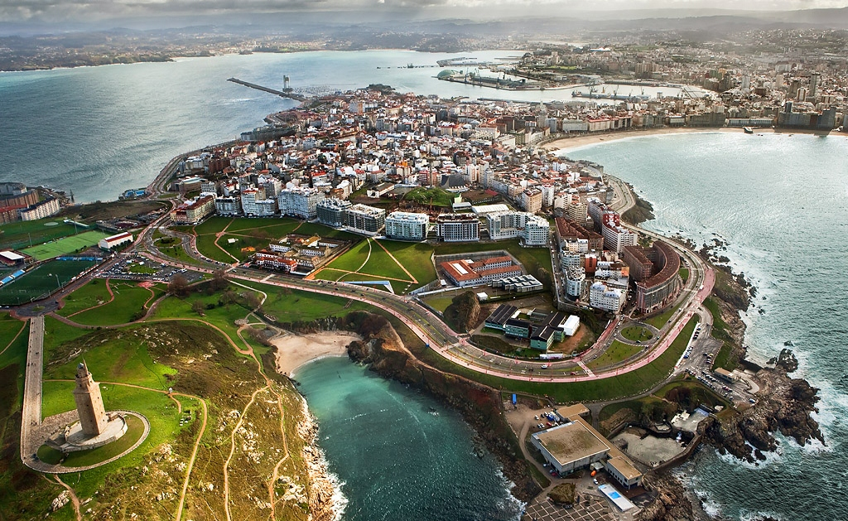
Figura 1. Espectacular vista aérea de A Coruña. Fuente Arial Nova o Arial 10.

Tables, such as Table I, are numbered using Roman numerals, and the text at the top of the table is in bold. Always use a blank line before and after the table. Use units of the International System whenever possible to facilitate the understanding of your presentation.
Figures and tables should appear as close as possible to the section of the text where they were first cited. It is important that before inserting the figure into the document, you verify:
- That the text appearing on them is completely legible.
- That it can be properly exported to PDF format.
The text in tables uses Arial Nova or Arial font with a size of 9 points and a line spacing of 1.15 points. The header text can be emphasised using bold font and the text in the first column if necessary.

Table I. Table example (Arial Nova or Arial 10).
Power (%) | Power (MWt) | Rod ejection time (s) | SCRAM signal | Set-point HPR (MWt) | Activation HPR (s) | Actuation SCRAM (s)
25 | 40.00 | 0.5 | HPR | 46.00 | 0.55 | 2.55
45 | 72.00 | 0.5 | HPR | 82.80 | 0.54 | 2.54
50 | 80.00 | 0.5 | HPR | 92.00 | 0.54 | 2.54
55 | 88.00 | 0.5 | HPR | 101.20 | 0.54 | 2.54
60 | 96.00 | 0.5 | HPR | 110.40 | 0.54 | 2.54
70 | 112.0 | 0.5 | HPR | 128.80 | 0.54 | 2.54

CONCLUSIONS
You can include an additional nomenclature section if you have used many abbreviations. This will make your paper more readable and compact.

ACKNOWLEDGEMENTS
This year, the Technical Committee of the Annual Meeting would like to extend special thanks to all authors and speakers for the work you do—not only in preparing your contributions, but also in coordinating within your organizations to bring new presentations each year. Without you, this technical program would not be possible.

REFERENCES

[1] A. Autor1, B. Autor2, y C. Autor3, «Título del artículo científico», Abrev. Revista, vol. XX, pp. YY-ZZ, ene. 2012, doi: 10.1016/j.anucene.2012.03.022.
[2] A. Autor1, B. Autor2, y C. Autor3, «Título del artículo de revista», Nombre de la Revista p. X, ene. 2021.
[3] A. Autor1, B. Autor2, y C. Autor3, «Título del artículo de conferencia», Ciudad, País, 2018.
[4] A. Autor1, B. Autor2, y C. Autor3, Título del libro o manual, 2018.
[5] «Nombre de la página web», Título extendido de la página web, 2021. página web (accedido 9 de diciembre de 2021).

